**JOINTS OF UPPER LIMB**

**Joints of shoulder girdle and upper arm**

* Acromio – clavicular joint
* Sterno – clavicular joint
* Gleno-humeral joint (shoulder joint)

**Joints of forearm**

* Elbow joint
* Wrist joint

**Joints of the hand**

* Trapezio metacarpal joint (TM)
* Carpometa carpal joint (MCC)
* Metacarpo phalangeal joint (MCP)
* Interphalangeal joint (IP)
* Proximal interphalangeal joint (PIP)
* Distal interphalangeal joint (DIP)

**Diagram showing joints of hand**

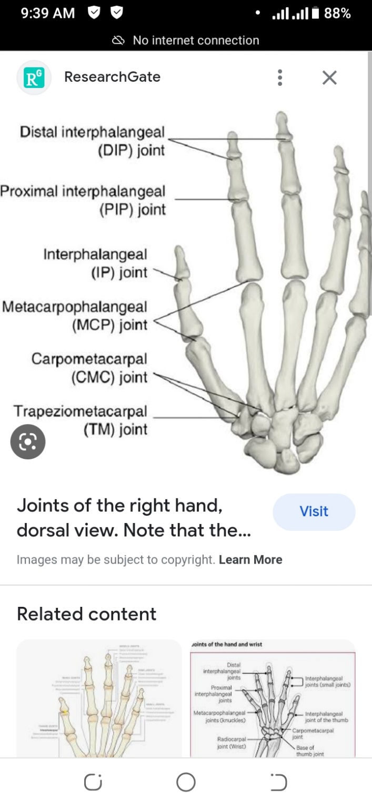

**Shoulder joint**

**Type:** Ball and socket joint

* It is also synovial

**Articulating surfaces:** Head of humerus (ball)

* Glenoid cavity of scapula (socket)

**Structures in the joint**

**Joint capsule:** This is a sac that contains lubricating fluid called synovial fluid.

* It encloses all sides of the shoulder joint.

**Synovial membrane**: Lines the joint capsule and produce synovial fluid for joint lubrication.

**Ligaments:** They are several and hold the joint firmly.

**Bursae:** They produce synovial fluid which reduce friction in the shoulder joint.

**Stabilizers of shoulder joint**

1. **Ligament**

Coraco- clavicular ligament- This is composed of two ligaments (Trapezoid and conoid ligaments)

* It connects clavicle and coracoid process of scapula.

Gleno-humeral ligament – connects glenoid cavity of scapula to head of humerus.

Coraco-Humeral ligament- Connects coracoid process of scapula to greater tubercle of humerus.

Transverse humeral ligament – this span (circles) the greater and lesser tubercles of humerus.

Coraco-acromial ligament – connects coracoid process and acromion process of scapula

1. **Joint capsule**- this encloses all sides of shoulder joint holding it firmly.
2. **Shape of articular surfaces**- The head of humerus fits well in the glenoid fossa of scapula.
3. **Muscles of the shoulder**- All muscles of the shoulder holds the joint firmly

**Blood supply to shoulder joint**

It is supplied by the following arteries.

* Circumflex (axillary) artery
* Suprascapular artery
* Sub scapula artery

**Nerve supply to shoulder joint**

It has three nerves

* Circumflex (axillary nerve)
* Musculo cutaneous nerve
* Supra scapula nerve

**Movements of shoulder joint**

* Flexion
* Extension
* Abduction
* Adduction
* Internal rotation
* External rotation
* Circumduction

**Diagram of shoulder joint**

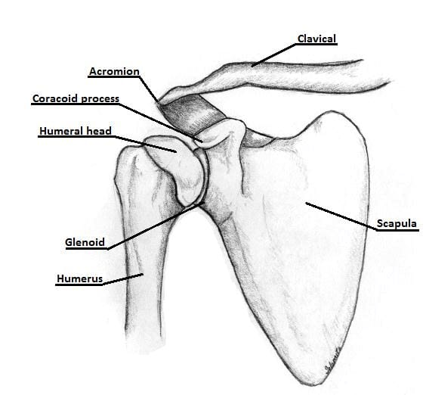

**The Elbow joint**

**Type:** It is a hinge joint

* It is also synovial

**Articulatory surfaces:** Trachlea of humerus and trachlea notch of ulna

* Capitulum of humerus and head of radius.

**Structures in elbow joint**

**The capsule:** This is a water tight sec that contains lubricating fluid called synovial fluid.

* It surrounds the elbow joint.

Synovial membrane: This lines the joint capsule. It produces synovial fluid for joint lubrication.

**Blood supply to elbow joint**

* Radial artery

**Nerve supply**

* Radial nerve
* Median nerve
* Musculo cutaneous nerve
* Ulna nerve

**Stabilizers of elbow joint**

1. **Ligaments** – Medial (ulna) collateral ligament.

Lateral (radial) collateral ligament.

1. Forming shape of articular surfaces.
2. Joint capsule- it encloses all sides of the joint.
3. Muscles that pass across the elbow joint.

**Movements of elbow joint**

* Flexion and
* Extension

**Diagram showing the elbow joint**

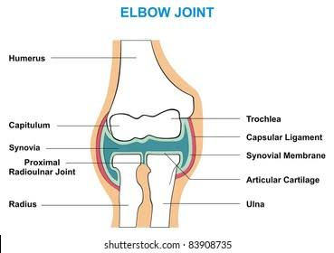

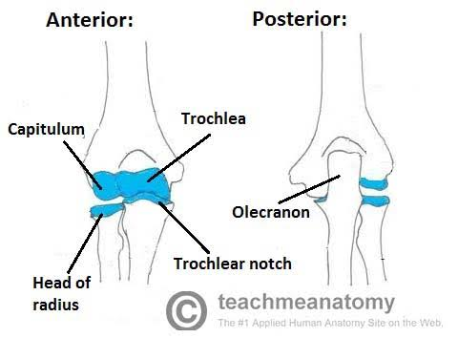

**Radio-ulna joint**

The radius and ulna are joined by three separate joints

* Proximal radio-ulna joint
* Middle radio-ulna union
* Distal radio-ulna joint

**The proximal radio-ulna joint**

**Type:** It is a pivot joint

* It is also synovial

**Articulating surfaces:** - Head of radius

* Radial notch of ulna
* Annular ligaments

NB/ The annular ligament is a strong fibrous band which attaches anterior and posterior sides of radial notch of ulna forming a complete ring where head of radius rotate.

**The middle radio-ulna union**

**Type:** It is a syndesmosis joint between shaft of radius and shaft of ulna

A syndesmosis joint is a fibrous joint in which adjacent bones are linked by a strong membrane or ligaments.

It is joined by two structures.

1. Oblique cord- A small fibrous cord running from lateral side of ulna tuberosity downward and laterally to below radial tuberosity.
2. The interosseous membrane- This connects the shaft of radius and ulna

**The distal radio-ulna joint**

Type: It is a pivot joint

* It is also synovial

**Movements of radio-ulna joints**

Pronation and supination of forearm

**Diagram of radio-ulna joints**

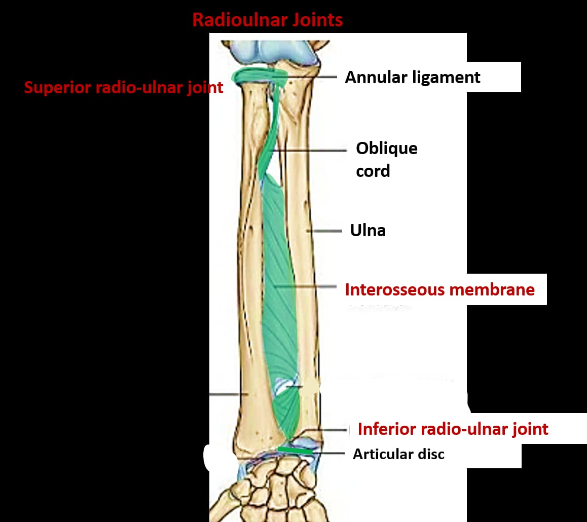

**The wrist joint**

Type: It is a condyloid (ellipsoid) joint

* It is also synovial

Articulating surfaces: Distal end of radius

* Carpal bones (scaphoid, lunate and triquetral)

**Structures in the joint**

Joint capsule- This is supports all the eight carpal bones.

Synovial membrane- This lines the joint capsule. It produces synovial fluid for joint lubrication.

Articular disk – A triangular shaped structure placed below distal end of ulna which binds lower end of ulna and radius together firmly.

**Blood supply to wrist joint**

* Radial artery
* Ulna artery

**Nerve supply to wrist joint**

* Median nerve
* Radial nerve
* Ulna nerve

**Stabilizers of wrist joint**

Ligaments

1. Scapho-lunate ligament – connect scaphoid and lunate bones.
2. Anterior radio carpal ligaments- connect distal end of radius and scaphoid, lunate and capitate bones on the anterior aspect of the joint.
3. Radio-collateral ligament- connect styloid process of radius and scaphoid bone.

Joint capsule – This binds all the eight carpal bones.

**Movements of wrist joint**

* Flexion
* Extension
* Abduction (Radial deviation)
* Adduction (Ulna deviation)

**Diagram of the wrist joint**

